



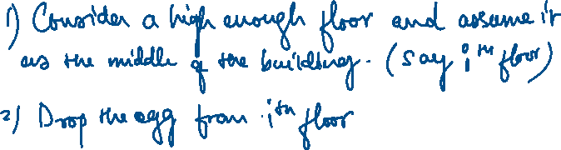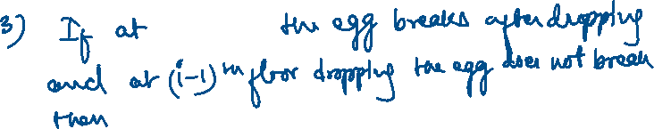

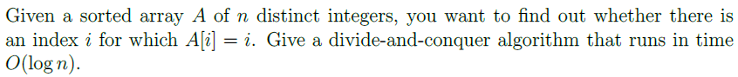



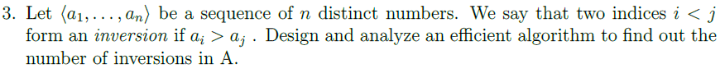

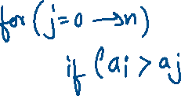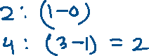

<https://www.geeksforgeeks.org/inversion-count-in-array-using-merge-sort/> - Using merge sort.



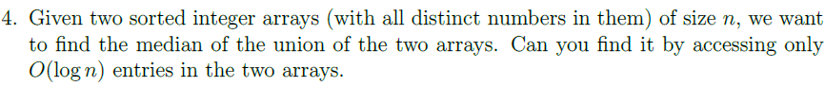

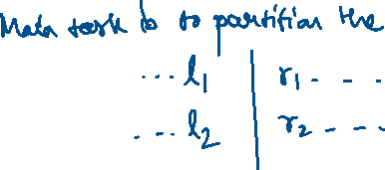

<https://www.geeksforgeeks.org/median-of-two-sorted-arrays/>

<https://www.youtube.com/watch?v=F9c7LpRZWVQ>



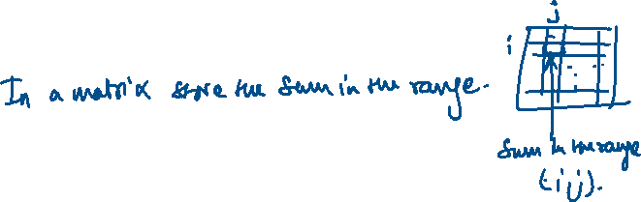

<https://www.geeksforgeeks.org/minimum-length-subarray-sum-greater-given-value/>

